Grade 7 Accelerated · Unit 5 · Lessons 2–3  Scale Factor: Perimeter and Area  Question Bank - Additional 5.02 ANSWER KEY | Name  Date  Period

Show your work. Circle your final answer.
For questions 1 through 4, find the copy's perimeter or area.
1. Perimeter 26 cm, 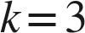.
78 cm

2. Area 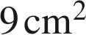, .
81 cm²
9 × 9.

3. Area 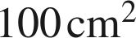, 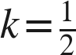.
25 cm²
100 × ¼.

4. A 4 cm by 5 cm rectangle, 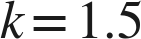. Perimeter and area of the copy.
P = 27 cm, A = 45 cm²
18 × 1.5; 20 × 2.25.

For questions 5 through 7, find , or the ratio asked.
5. Areas 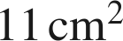 and 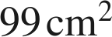. Find .
k = 3
99 ÷ 11 = 9 = k².

6. Areas 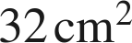 and 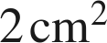, original to copy. Find .
k = ¼
2 ÷ 32 = 1⁄16 = k², so k = ¼.

7. Perimeters 10 cm and 50 cm, original to copy. What is the area ratio?
25
k = 5; k² = 25.

Choose one.
8. A figure with area 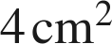 is scaled by 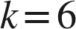. What is the copy's area?
○ A. 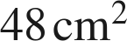
● B. 
○ C. 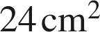
○ D. 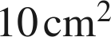
B
4 × 6² = 4 × 36.

